Copy and paste the words and pictures into the matching boxes.
Name:

2 bats
1 candy
4 cats
3 pumpkins
5 ghosts
1 witch
3 ghosts, 1 cat
2 bats, 1 pumpkin
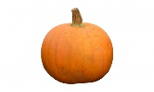
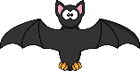
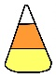
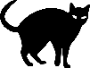
Pumpkin
Candy Corn
Cat
Ghost
Bat
Witch

